Prayer for Whyalla
24th May 2020

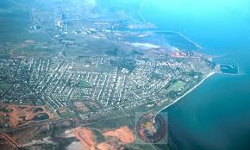
I would like to welcome you to pray for our city Whyalla. Each week we spend 15 to 20 minutes during our service praying for our city. We are unable to pray together but please put some time aside to pray. You could pray while listening to the service songs, you could choose to pray in your bedroom, lounge room, patio, at the beach, or favourite outside environment.
This morning I would like to focus on Whyalla transitioning to stage 2 of the covid19 restrictions.
- People meeting people where they are.
- Relationships renewed within the community.
- A feeling of peace and tranquillity.
- Being willing to go the extra mile with others.
- Rules being clear and concise.
- Bible studies restarting.
Let these verses encourage and guide you as you pray for Whyalla
John 16:33: “I have told you these things, so that in me you may have peace. In this world you will have trouble. But take heart! I have overcome the world.”
Matthew 5:9: “Blessed are the peacemakers, for they will be called children of God.”
1 Thessalonians 5:13: Hold them in the highest regard in love because of their work. Live in peace with each other.
“Lord Jesus we come to you and praise you for all you have done for us as individuals, church community and the wider Whyalla community. As restrictions ease keep our city safe. We pray you put us where we can shine your light. While people have more time within their home we pray for safety, tranquillity, peace and clarity. In Jesus name Amen.”
Have a lovely week. I look forward to seeing you all soon.

Karol

