Prayer 7 June 2020

I thought this week we could pray for Whyalla and the things that divides us. From the 27 May to the 3 June was National Reconciliation Week.
Although I really don’t know enough about the history and culture of the Aboriginal People and it can be controversial, I can pray and ask God to help me, give me insight and wisdom, when I am at the shops or out and about around town and so easily judge what I don’t fully understand or comprehend.
A google search for reconciliation showed this….
1. the restoration of friendly relations.
2. the action of making one view or belief compatible with another

I thought it was funny that the next box showed the true meaning of reconciliation – which shed a Christian perspective on it.

What is the true meaning of reconciliation?
Reconciliation, in Christian theology, is an element of salvation that refers to the results of atonement. Reconciliation is the end of the estrangement, caused by original sin, between God and humanity.

A friend of mine shared this with us:
The message of gospel reconciliation has important implications for Christian thought about the reconciliation process in Australia. Primarily, it means that genuine reconciliation is found in Christ by the gospel. The sad history of the mistreatment of the Indigenous people of Australia and the sins which stain our past are only properly overcome in the work of Christ. So, the fullest contribution which the Christian church can make to national reconciliation is to proclaim Christ.
Easy proclaim Christ, I don’t know about you but I’m actually not so sure that I am proclaiming Christ when I am just walking past people in the shops. So, let’s make this a prayer for Whyalla, National Reconciliation Week has come and gone. Let’s pray and ask God for continued opportunities to share His reconciliation - to proclaim Christ wherever we go. However, He wants us too. Ask that the Holy Spirit will prompt us. That we will look up for our busy days and acknowledge, show respect, smile, help where we can with the knowledge that we have Christ’s reconciliation in us.
Through the fall, both the vertical relationship (us and God) and the horizontal (us and each other) has been broken. (I’d also say there’s a third relationship of us and creation - Colossians 1:20 and through him to reconcile to himself ALL THINGS whether things on earth or things in heaven, by making peace through his blood, shed on the cross. but that doesn’t often get mentioned…) A broken relationship needs to be reconciled and all of these can only be done because of the work of Jesus at the cross.

Prayer points:
- Thank God for the Cross
- Repent of the sins that divide us from God
- Repent of the sins that divides us from other people
- Pray for the brokenness in the Aboriginal communities in Whyalla
- Pray for the Christian Aboriginals that they will be strengthened, and God will use them
- Pray and ask God what you can do to be His light in the community
- Pray for the courage to do as He leads you.

Thank you
Delani
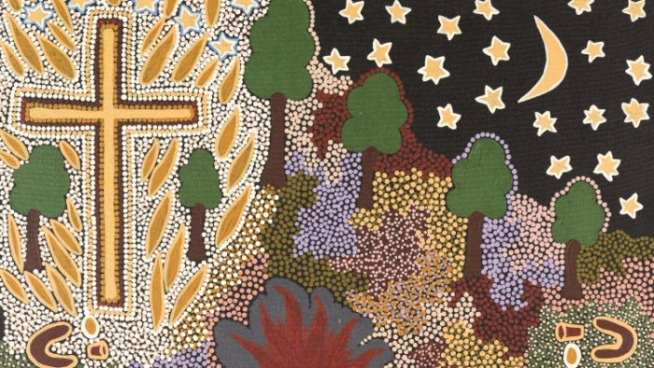

Our Mob, God’s Story – Bible Society

